**Step 1**: Click on the profile icon on the rightmost top corner and select > manage your google account.

**Step 2** : You can see the less secure app access is no longer supported by google after May 2022.

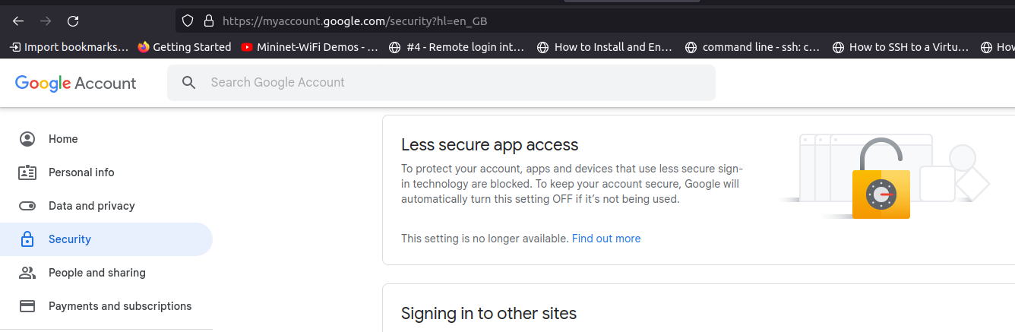

**Step 3** : Here you need app password, for using mail services on raspberry pi.

Go to 2-step verification and enable it:

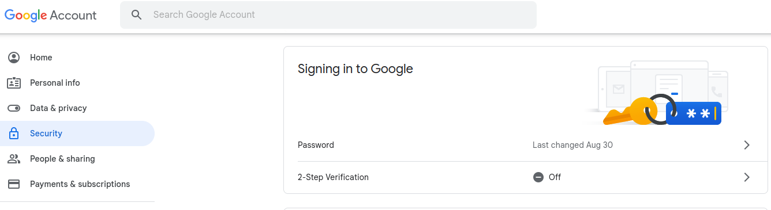**Step 4**: Click on get started

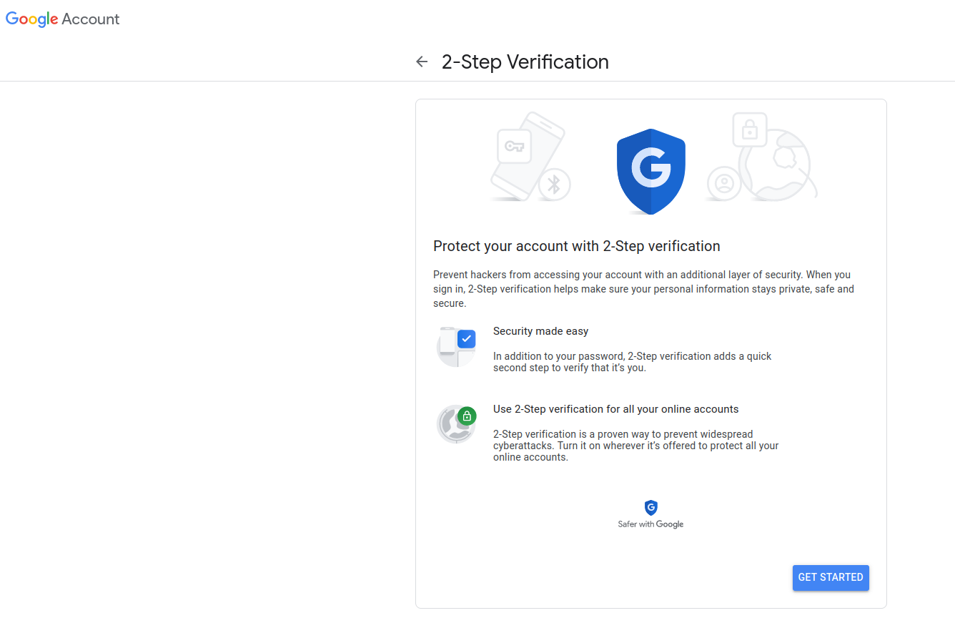

Use any of your existing devices or select “Show more options”, with which you can use text message or a voice call.

**Step 5**: Enter your mobile number, and verify it.

Verify the message and 2 step verification should be enabled

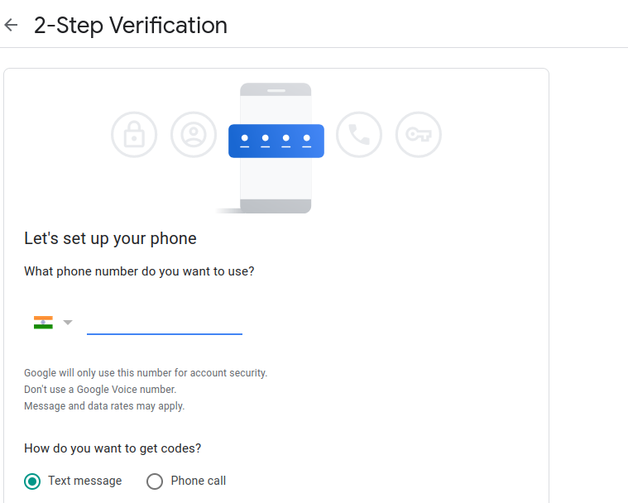

**Step 6**: You can see the 2-step verification is on and app passwords is visible.

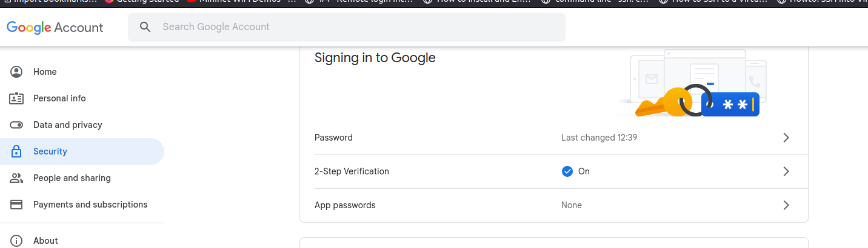

**Step 7**: Select Other(Custom name)

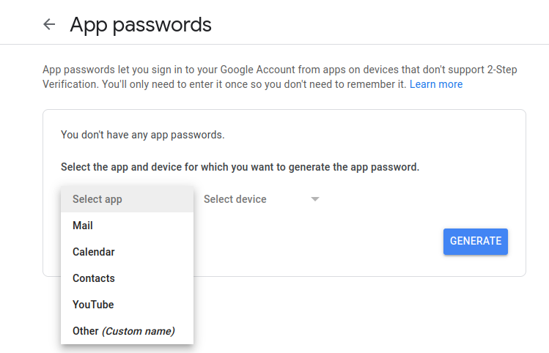

**Step 8**: Enter name and click generate.

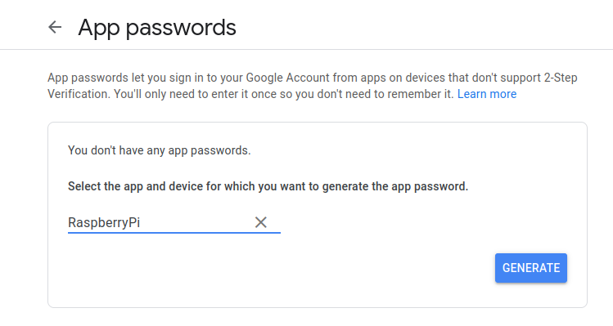

**Step 9**: Use this instead of your regular password in the code.

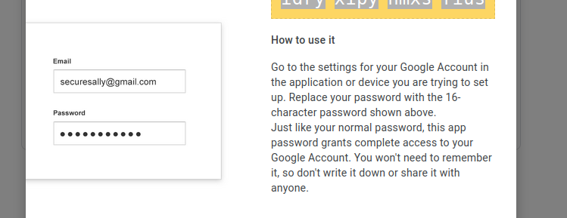

**Step 10:** Now test the simple mail in raspberry pi, if it works:

import smtplib

server=smtplib.SMTP('smtp.gmail.com', 587)

server.ehlo() #Not mandatory, but recommended

server.startls()

server.login("Your Email id", "Here the above app password should be give")

msg="Raspberry pi email test"

server.sendmail("sender’s email id", "reciever’s email id", msg)

server.quit()